OPEN LETTER TO THE MINISTRY OF ENVIRONMENT AND FORESTS

29th October 2004

WILL THE DRAFT NATIONAL ENVIRONMENT POLICY REALLY SAFEGUARD INDIA’S ENVIRONMENT?

The draft National Environment Policy (NEP) dated 15th August 2004 was put up on the website of the Ministry of Environment and Forest with a deadline for public responses by 30th October 2004. The draft NEP is an important document, especially because it articulates the government's view on the relationship between environment and development.

However, citizens’ groups across the country have expressed serious reservations about the process and substance of the NEP:
- The process so far has been opaque and undemocratic, despite MoEF’s claim to have extensive consultations. NGOs known for their environmental record, or communities with maximum dependence on the environment have not been part of the process of formulating the NEP draft. Nor is the current process of seeking public inputs very participatory, since the draft is only available on a website, that too only in English, and there are no known plans for consultations with local communities, although a consultation with corporate and bureaucrats has apparently been planned.
- The draft NEP contains serious internal contradictions with some good elements being negated by an overall tendency to subordinate environmental concerns to short-term economic interests, apart from grossly inadequate and ambiguous action points. It displays a very strong ’economic fundamentalist’ approach, which assumes that market and economic instruments will solve basic environmental problems. This is also reflected in the proposed monitoring of the NEP by the Cabinet Committee on Economic Affairs rather than by an environmental agency. It could pave the way for weaker regulatory measures, including in impact assessment and coastal zone notifications. It is also scientifically and technically unsound, leaving huge gaps in conservation measures, and ignoring many technological innovations.

Given these basic problems, we the undersigned reject the NEP draft in the present form. The Government of India needs to initiate a fresh process of drafting and finalising a National Environment Policy, with widespread involvement of civil society organisations from the start.

India needs a bold and forward-looking policy on the environment. Such a policy should give environment the central place it deserves in India’s planning process. However, the draft National Environment Policy (NEP) posted on the website of the Ministry of Environment and Forest, for public comments, scarcely serves this purpose. Rather than helping to safeguard the environment, the draft NEP seems to be an attempt to actually further undermine ecological sustainability (and even existing policies/ laws/ processes), by providing a ‘green face’ to the current process of environmentally destructive ‘development’. The draft’s overall orientation, and its actual operative part is largely ‘business as usual’, which will hardly help to reverse the country’s environmental crisis or to safeguard the interests of either wildlife or the millions of people who depend directly on the natural environment.

Several citizens’ groups have identified serious flaws in both the process and substance of the draft NEP. The points listed below summarise several critiques that citizens and organisations have already sent to MoEF.
- The process of drafting the NEP, and of discussing it in the public domain, has been profoundly undemocratic. There has been very little meaningful consultation with environmental NGOs, and perhaps none with village communities. The fact that the draft is still only available on the internet, only in English, and with a very short time period (of 75 days) for public inputs, puts it out of reach of most people in India. How can the government formulate a policy on environment without consulting with local communities, who have highest direct dependence on the environment?
- The NEP falls short of the essential elements of a policy statement. A policy must start with a clear statement of objectives and vision: what problem it is addressing, what state of affairs it aims to create, what long-term vision it seeks to articulate. It must then refer to other existing policies on the subject, analyse their successes and failures, and indicate the need for the new policy statement based on this analysis. The policy document needs to be brief, essentially laying down the broad principles that would determine decision-making, investment and action rather than go into details - such as the mentioning of specific sites – that change ever so often. A sound policy also needs to indicate the interfaces with other related policies (in this case with sectors like energy, water, agriculture, transport, infrastructure and tribal affairs), in particular to highlight the over-riding importance that environment should be given in relation to such policies. The draft NEP is lacking on most of these counts.
- The draft attempts to weaken the already inadequate regulatory mechanisms meant to safeguard the environment. This is illustrated by its approach to Environmental Impact Assessments, Coastal Regulation Zone notification, and other existing regulations. For instance, the draft NEP highlights the need to ‘reduce delays’ in environment clearances of projects but ignores the fact that most delays are caused by inadequate, incorrect or improper fulfilment of the mandatory requirements under the Environment Protection Act or Forest Conservation Act. It is ironical that the draft NEP condones the view that environmental legislations are to blame for delaying developmental processes, sidelining the fact that unsustainable ‘development’ processes destroy the environment! There is an urgent need for a comprehensive strengthening of the Environment Impact Assessment procedures by making it mandatory from the very start of project planning stage, ensuring meaningful public participation, and making all decisions transparent to the public.
- The draft pays lip service to the livelihood dependence and rights of adivasis and other ecosystem-dependent communities in India. It identifies alienation of such communities as a serious problem, and stresses on the need to ensure forest rights to adivasis…but in its operative part, does not go into how alienation can be reversed, or how forest/resource rights are to be restored. In reverting to the notion of “stakeholders,” where all parties are treated at par, it ignores the enormous difference in leverage that interest groups such as big corporations wield, and fails to distinguish between the right to survive (of adivasis and other ecosystem-dependent people) and the privilege to conduct business (of corporations).
- The draft displays a predominantly materialistic and anthropocentric view of the environment, ignoring the basic ethical imperative of conserving nature, and leaving out any discussion of the moral and cultural relations of humans with nature. It is also very weak on indigenous approaches to environment, including knowledge, innovations, traditions, practices, and technologies, mentioning only one or two specific facets of these.
- The draft NEP does not have a coherent vision of genuine decentralisation and grassroots empowerment. Though it says a few general things in this direction, the operative strategies and actions have hardly anything on how natural resource governance is to be managed by and from the level of local communities, or how current structures that centralise all powers in the hands of a small bureaucracy are to be changed. While it declares that the government is only a custodian of India’s environment, holding it in trust for citizens, it does not go into how this can be operationalised through a truly public-controlled decision-making process. In the absence of a concrete framework to ensure accountability and public participation at state and local levels, the NEP’s attempt to decentralise project clearances and other decisions to these levels may sound progressive but will in fact be a dangerous gamble. The provisions of the draft policy actually go against the spirit of the government holding the environment in trust.
- The draft NEP suffers from several internal contradictions. For instance, though it talks throughout about participatory approaches, in many parts it displays a non-participatory vision, e.g. it continues the current exclusionary approach to wildlife conservation (especially protected areas, where such an approach has caused immense human misery and serious conflicts that threaten wildlife conservation itself), and it completely ignores hundreds of initiatives by communities to conserve natural ecosystems and wildlife.
- The draft is weak from a technical and scientific perspective, missing out critical conservation priorities (such as marine areas, or wildlife conservation outside protected areas), ignoring a number of innovative technological solutions, failing to move into integrated land and water use planning, and leading to unacceptable compromises of environmental standards in lieu of other considerations. It has an inadequate approach to technical solutions regarding issues like pollution. For instance, the policy does not highlight the need to integrate the ‘best practices’ into the very beginning of a production cycle.
- The review mechanism for the draft NEP is faulty, in that it places the responsibility on the Cabinet Committee on Economic Affairs rather than on an agency with credible and independent environmental expertise. The review mechanism needs to be fully participatory, independent, and centrally involving environmentalists and communities.

In the context of the above weaknesses, the draft NEP even departs significantly from the approach professed in the government’s Common Minimum Programme (CMP), especially from the CMP’s stress on giving priority to the “weaker sections of society”, ensuring genuine political decentralisation, stopping evictions of tribal communities, and making the government “accountable at all times”. There is not a single mention of gender in the entire NEP, nor is there a mention of labour or labour unions. . On the contrary, and shockingly, the draft NEP in many places sounds suspiciously like the World Bank’s recently announced Country Assistance Strategy for India…especially in its cynical advocacy of market-based instruments, review of regulatory mechanisms, and the fashionable new way of bringing in private sector interests through “public-private partnerships”.

For the reasons given above, the signatories to this letter reject the NEP in its present form.

We insist that the MoEF should start afresh with a truly consultative process of formulating the NEP, making clear the reasons why such a policy is to be formulated. It is instructive that such a widespread process was carried out during the preparation of the National Biodiversity Strategy and Action Plan (NBSAP), facilitated by the MoEF itself. This process deliberated on many of the above substantive points, and came out with detailed strategies and actions in the draft national plan jointly with communities most dependent on nature and natural resources. It gave central priority to ecological security and to the livelihood security of such communities, also what any NEP should focus on. Remarkably both the process and the outcomes of the NBSAP seem to have been totally ignored by MoEF while producing the draft NEP.

Two previous Open Letters by environmental groups and people’s movements over the past two months have focussed on critical lapses in environmental decision-making. Were the MoEF keen on wider "consulting" with the public on the NEP, one indicator would have been to engage in a discourse with signatories of these letters, inviting their views on how best the NEP could truly reflect India's diverse environmental concerns. But the MoEF’s failure to even acknowledge these efforts indicates an attitude of non-engagement. The present MoEF process of "consultation" on the NEP therefore appears to be mere a greenwash to claim that widespread participation has taken place, when in effect no such process is taking or has taken place.

We urge the following steps:
- Urgently initiating a widespread participatory process of obtaining feedback to formulate a fresh NEP, and holding nation-wide consultations on a new draft rather than tinkering with the existing draft.
- Stating clearly the justification and objectives of a NEP, including a clear long-term vision of India’s environment, analysis of the linkages to past policies/action plans and their successes/failures, and an explicit commitment to put environmental security and human survival values above all short-term economic interests.
- Translating the draft that emerges from a fresh process, into all major Indian languages, circulating these versions in hard copy through local institutions, and holding public consultations in various parts of India.
- Making special efforts towards reaching out to the women & men of local communities of farmers, fishers, pastoralists, and others, especially adivasi peoples.
- Uploading all comments from citizens, other govt. agencies, states, on the MoEF website, to ensure an element of transparency.
- Coming out with a radically different NEP through the above process, one that places the environment (including biodiversity and wildlife) and livelihoods based on natural resources, as the central concerns of India’s planning and development process. In this the positive elements of the current draft (such as the Precautionary Principle, the doctrine of Public Trust, the need to review macro-economic policies, securing adivasi rights over forests and other natural resources, etc) can be carried forward, but within an overall context and operative framework that actually strengthens environmental conservation.

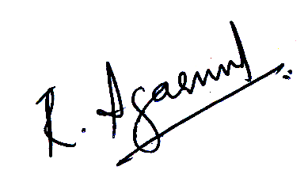

Ravi Agrawal (Toxis Link)
H2 Jangpura Extension, New Delhi – 110014
Tel: 011-24321747, 24328006; Fax: 24321747; Email: ravig@ndf.vsnl.net.in
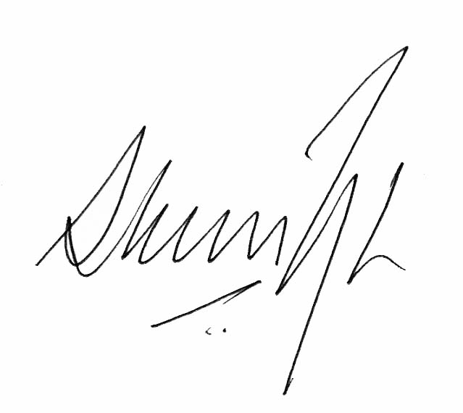
Shekhar Singh (National Campaign for People's Right to Information)
C 17A Munirka, New Delhi – 110067
Tel: 011 – 26178048; Email: shekharsingh@vsnl.com
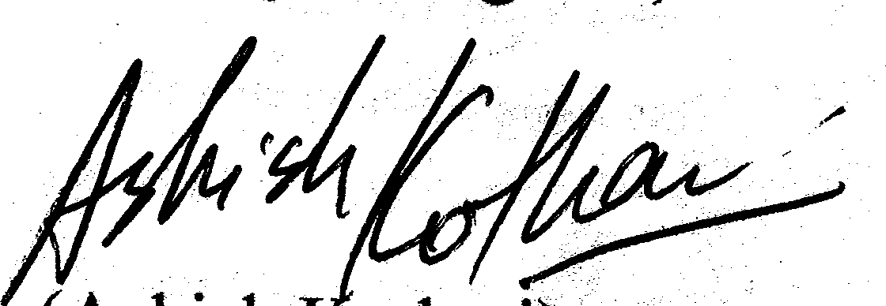
Ashish Kothari/ Bansuri Taneja (Kalpavriksh)
J 20, Jangpura Extension, New Delhi-110014
Ph: 011- 24316717; Email: kvrikshdelhi@yahoo.com; ashishkothari@vsnl.com

On behalf of:

- Binoy Acharya, UNNATI, Organisation for Development Education
- Ravi Agarwal, Toxics Link
- K. Alleya, Orissa Traditional Fish Workers Union
- Dr. Kripa Ananthpur
- Harry Andrews, Madras Crocodile Bank Trust & the Andaman and Nicobar Islands Environmental Team
- S.K. Anwar, Centre for World Solidarity, Hyderabad
- Gautam Bandyopadhyay, People’s Alliance For Livelihood Rights, Raipur
- Jayanta Bandopadhyay, Environmentalist, Kolkata
- Seema Bhatt, Biodiversity Consultant.
- Shiraz Bulsara, Kashtakari Sanghatna, Maharashtra
- Pradip Chatterjee, Society for Direct Initiative for Social & Health Action(DISHA), Kolkata
- B. Chittiama, , Samudram, (Orissa federation of Marine Women Fishworkers Organisation
- Hari Dang, The Third World Education Society
- Madhu Dhodi, Kamgar Va Mazoor Sangh, Maharashtra
- Y.D. Singh/Arun Mani Dixit, Gujarat Institute of Desert Ecology, Bhuj, Kutch.
- Sunita Dubey, Independent Researcher.
- Madhumita Dutta, The Other Media, Delhi
- Ritwick Dutta, Lawyer, Delhi
- Ashish Fernandes, Ecologist Asia
- C.K. Ganguly, Timbaktu Collective and Voluntary Action Network, Anantapur
- C.P. Geevan, Centre for Environment & Social Concerns, Bhuj.
- Colin Gonsalves, Socio-Legal information Centre, Delhi
- Soumitra Ghosh, NESPON
- Dilip Gode, Vidarbha Nature Conservation Society, Nagpur
- Nandita Hazarika/ Goutam Narayan, EcoSystems- India, Guwahati, Assam.
- Bulu Imam, Sanskriti, Hazaribagh
- Ramaswami R. Iyer, Former Secretary, Ministry of Water Resources, Delhi.
- Bharat Jairaj, Consumer and Civic Action Group, Chennai
- Jasveen Jairath, Hyderabad.
- Kailash Jani, Ganjam Zila Adivasi Manch, Orissa
- Nityanand Jayaraman, Independent Journalist/Researcher, Chennai.
- Arun Jindal, Society for Sustainable Development, Karauli, Rajasthan.
- Madhu Kishwar, Manushi, Delhi
- Ashish Kothari/Bansuri Taneja, Kalpavriksh, Pune & Delhi
- Smitu Kothari/Ramananda Wankheirakpam, Lokayan and Intercultural Resources, Delhi
- Kundan Kumar, Researcher, Orissa
- Bhawani Shanker Kusum, Gram Bharati Samiti, Jaipur
- Souparna Lahiri, Delhi Forum.
- Sharad Lele, Centre for Interdisciplinary Studies in Environment & Development, Bangalore
- Syed Liyakhat, EQUATIONS, Bangalore.
- Harsh Mander, Delhi
- Thomas Mathew, Wildlife Trust of India.
- Samir Mehta, Bombay Environmental Action Group, Bombay
- Subhash Mendhapurkar, Social Uplift Through Rural Action, Himachal Pradesh
- Shalabh Mittal, Pravah, Delhi.
- T. Mohan, Advocate, Chennai.
- Biswajit Mohanty, Wildlife Society of Orissa
- Fr. Victor Moses, St. Xavier's Social Service Society, Ahmedabad, Gujarat
- Simanchal Nahak, Rushikulya Royat Mahasabha Sanjukta Nayak, Orissa
- Sanjukta Nayak, SWOSTI, Orissa.
- Shweta Narayan, The Other Media, Chennai.
- Neelesh, WASSAN, Hyderabad.
- M. Nizamudeen, FEDCOT, Tamil Nadu
- Tushar Pancholi,Paryavaraniya Vikas Kendra, Rajkot
- Mangaraj Panda, United Artists’ Association, Ganjam, Orissa
- Mahesh Pandya, Paryavaran Mitra (Centre for Social Justice), Gujarat.
- Rekha Panigrahi/ Y. Giri Rao, Vasundhara, Orissa.
- Vijay Paranjpe, Gomukh Trust, Pune
- M. B. Patil, Bombay.
- Medha Patkar, Narmada Bachao Andolan
- Sujit Patwardhan, Parisar, Pune.
- Pradip Prabhu, National Front for Tribal Self Rule, Dahanu.
- P. S. Prakash, Andhra Pradesh NGOs committee on PFM
- Indu Prakash Singh, Aashray Adhikar Abhiyan, Delhi
- M.K. Prasad, Kerala Sastra Sahitya Parishat.
- M Arjun Prasad, Telangana Natural Resource management Group-Network, Andhra Pradesh
- G. Pullaiah, Madanapalle, Andhra Pradesh.
- D. Raghunandan, Delhi Science Forum
- Asad Rahmani, Bombay Natural History Society
- Salam Rajesh, Manipur Nature Society, Imphal, Manipur.
- K. Ramnarayan, Resident Village Sarmoli, Member Van Panchayat, Uttaranchal,
- Suman Sahai, Gene Campaign , Delhi
- John Samuel, National Social Watch Coalition (Delhi) and CCDS (Pune)
- Leo Saldanha, Environmental Support Group, Bangalore
- Madhu Sarin, Development Planner, Chandigarh.
- P. V Satheesh, Deccan Development Society, Andhra Pradesh Coalition in Defence of Diversity, South Asia Network for Food, Ecology and Culture
- Neera Singh, Researcher.
- Samar Singh, Samarpan Foundation, Delhi.
- Savyasachi, Academic, Delhi.
- Shekhar Singh, National Campaign for People’s Right to Information, Delhi
- Subrata Sinha, Former Deputy Director General, Geological Survey of India, Kolkata
- D. Suryakumari, Centre for People’s Forestry, Andhra Pradesh.
- Aarthi Sridhar, Environmental Activist
- Prof. S. S. Talwar, Emeritus Scientist, Dept.of Physics, IIT Bombay
- Nalini Thakur
- David. M. Thangliana, Newslink, Mizoram.
- Emmanuel Theophilus, Munsiari, Uttaranchal.
- Jagat Thoudam, All India Manipur United Clubs Organisation
- C. Udayashankar, Hyderabad.
- Mallika Virdi, Sarpanch, Sarmoli-Jainti Van Panchayat, Uttaranchal
- Romulus Whitaker, Draco Films, Chengalpattus, Tamil Nadu.
- A.C. Zonunmawia, Centre for Environment Protection (CEP), Aizawl, Mizoram

