INDEX

ADOPT A LAKE SCHEME 2

LAKES LEASED 2
Kenchanahalli kere (Bache kere), Kengeri Hobli 2
Kundalahalli Kere, K.R.Puram, Hobli 4
Mahadevapura Lake, K.R.Puram Hobli 7

LAKES TO BE LEASED 10
Puttanahalli Lake , NH 209 ( Kanakapura Road) 10

EXPRESSION OF INTEREST 12

LAKES TO BE LEASED 12
Arakere, Bannerghatta Road 12
Begur Lake, Hosur Road 14
Bommasandra Lake, Hosur Road 16
Doddanekundi Lake, K R Puram 18
Hulimavu Lake, Near Hulimavu village, Bannerghatta Road 20
Naganaikana Lake, Begur village 22
Varthur Lake, North-west of Varthur 24
Yellammappa Chetty Lake, Northeast of K R Puram 27

ADOPT A LAKE SCHEME

LAKES LEASED

Kenchanahalli kere (Bache kere), Kengeri Hobli

Date of survey: 23/10/2008
Form filled by: Sruthi Subbanna & Nandini Chami, Environment Support Group

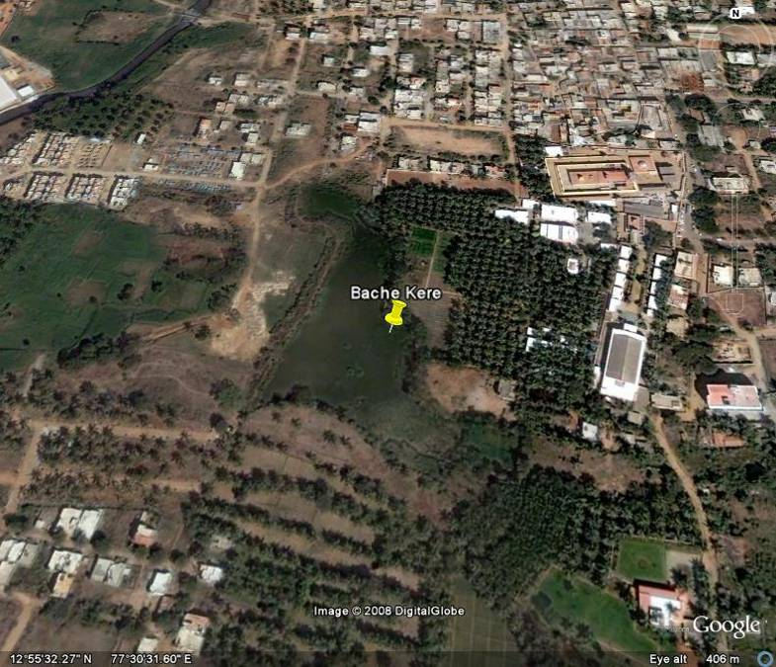
Google Earth Image of Kenchanahalli Lake

The Kenchanahalli Lake is referred to as Bachekere in the survey records. It is located at Kengeri Hobli, Bangalore South taluk. (at Sy no. 33 of Kenchenahalli village and Sy no. 43 of Pattanagere village). It is a small lake extending to 4 acres, 30 guintas. It has been leased out under the “Adopt a Lake scheme” to Rajarajeshwari Devasthana on 19/2/2007 for Rs. 25.117 Lakhs.

According to survey records, the boundaries of the lake are as follows:
On the North: Sy no. 1 of Kenchenahalli village
On the South: Sy no. 42 of Pattangere village
On the East: Sy No. 1, 2, 3 of Kenchenehalli village and Sy no. 46 of Pattangere village.
On the West: Sy no. 32, 34, 35, 36, 37, and 38 of Kenchenahalli village

The lake is extensively eutrophicated, and there is discharge of sewage into the lake from the south and western shores of the lake. One cannot see the sewage effluent pipe and the sewage being discharged because of the presence of wild vegetation, but one can clearly detect the presence of sewage because of its distinct smell. There is not much water in the lake and the little water that is left is black.

The area around the lake has a very foul smell. It is almost impossible to approach the lake as it is bounded on the north and east by temple property and the south and west are blocked by excessive overgrowth of vegetation. There is also dumping of garbage at the south and west bank of the lake.

Picture 1a: Temple wall abutting the lake and extensive growth of wild vegetation.

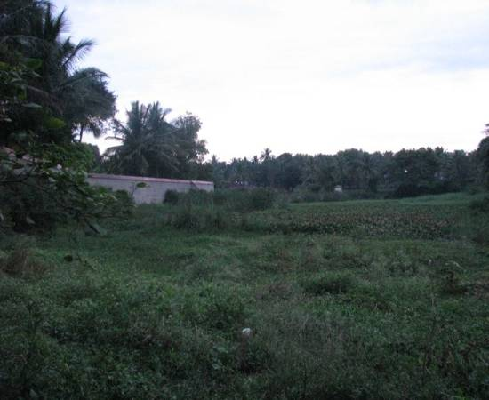

Picture 1c: The lake water is black and foul smelling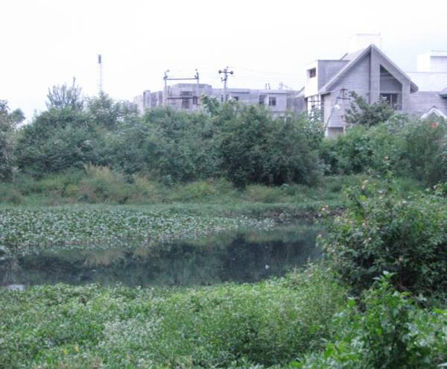

Picture 1b: Solid waste dumped along the south and west bank of lake

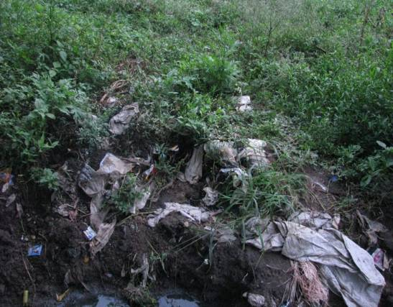

Kundalahalli Kere, K.R.Puram, Hobli

Date of survey: 23/10/2008
Form filled by: Sruthi Subbanna & Nandini Chami, Environment Support Group

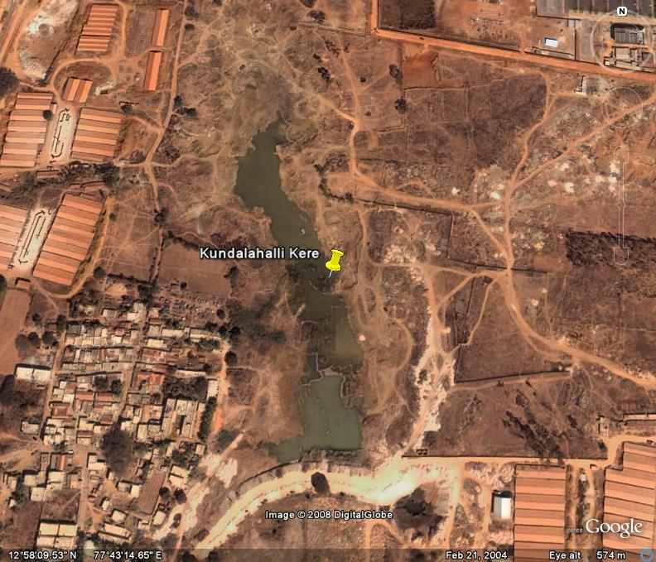
Google Earth Image of Kundalahalli Lake

The Kundalahalli lake is located at Kundalahalli, K.R.Puram Hobli, Bangalore. It is a medium size lake, extending to 30 acres, 20 guntas. It has been leased out under the “Adopt a Lake scheme” to M/s Kalyani Developers on 04/2/2006 for Rs. 1.73 Crores.

According to survey records, the boundaries of the lake are as follows:
On the North: Road & Sy. No. 27 & 28
On the South: Road
On the East: Sy No. 30, 39, 41
On the West: Road & Compound Wall of M/s. Kalyani Developers, Sy No. 2, 3, 4 of Kundalahalli village.

The lake water is murky, and the survey team noticed pieces of thermocol floating in the lake. The approach road adjoins the southern bank of the lake. Along the east bank, there is a significant amount of anchored vegetation. About 100 metres from the east bank, construction activities were being carried out. On the west bank, there was a small heap of rubble and a bore well from which water was being pumped out. Two electric towers can be seen standing in the lake, and they carry high voltage electric wires.

The survey team observed an outer & inner concrete wall, separated by a fence, on the northern bank. There was a small Basava Mantapa adjoining the lake, and some grass and other shoreline vegetation. The lake is extensively used for grazing cattle.

The fence along the south-eastern & eastern banks is broken in some places. There has been an attempt to develop a garden along the eastern bank, but this seems to have been abandoned, as the garden is overgrown and unkempt.

The survey team observed that the workers on the construction sites use the lake for bathing, swimming and washing clothes. At the south end, the survey team noticed fishing nets and a coracle, so it was evident that the lake is also used for fishing.

Picture 2a: Construction work being carried out near the east bank of the lake.

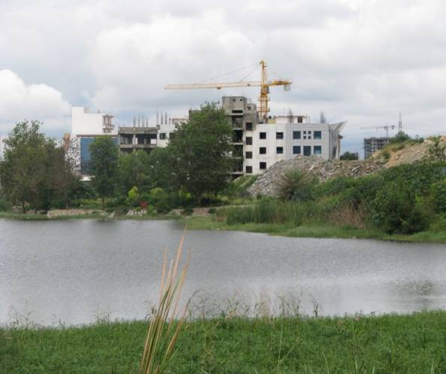

Picture 2b: One of the two electric towers erected on the lake.

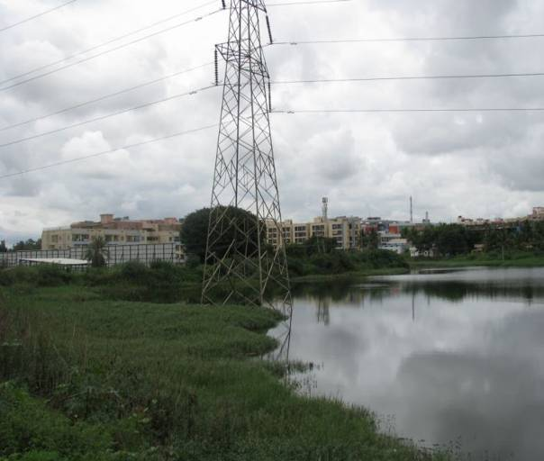

Picture 2c: Attempts along the east bank to develop a garden which has later been abandoned.

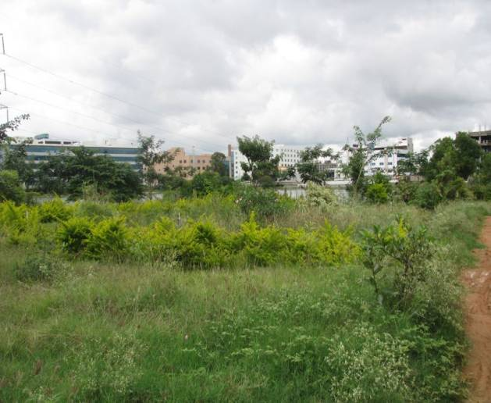

Picture 2e: Thermocol pieces drifting on the lake surface.

Picture 2d: Rubble dumped along the west bank.

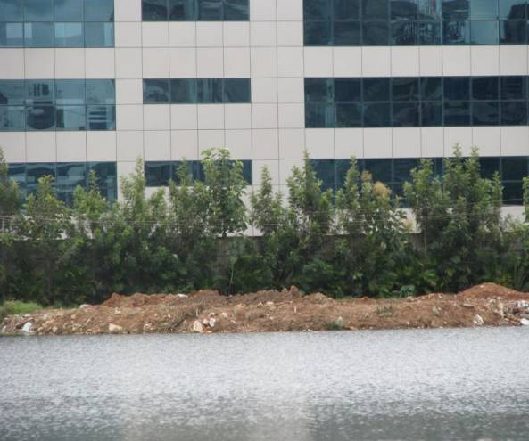

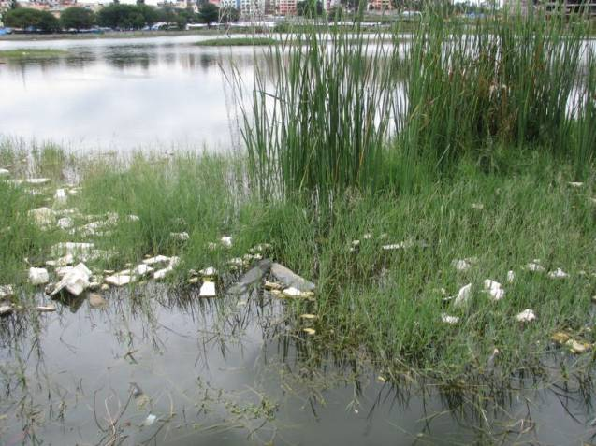

Mahadevapura Lake, K.R.Puram Hobli

Date of survey: 23/10/2008
Form filled by: Sruthi Subbanna, Nandini Chami, ESG

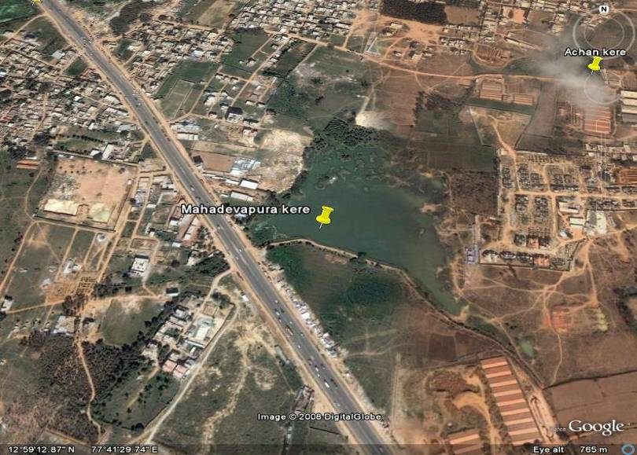
Google Earth Image of Mahadevapura Lake

The Mahadevapura Lake is situated in Survey No.7 of Mahadevapura village, K.R.Puram Hobli. It has been leased out under the “Adopt a Lake scheme” of the Lake Development to M/s Abhishek Developers on 16/2/2006 for 1.63 Crores.

It is a medium sized lake, and measures 26 acres 23 guntas. It is bounded on the South, and partly on the West, by the Ring Road.

An examination of survey records reveals the following details about the boundaries of the lake.
North: Sy No. 28 & 29.
South: Sy No. 51, 109,110,113,114,115,117,118 and Ring Road.
East: Sy No. 34,35,36,37,105,106

The water is murky, and there is excessive growth of aquatic vegetation at the north of the lake. Shoreline vegetation is present all along the bund located on the eastward side. A compound wall of a residential layout has been built adjoining the north bank, and an outlet pipe from the layout can be seen. While the team was carrying on the survey, there was no discharge from the pipe but enquiries posed to the fishermen revealed that there is occasional discharge of sewage from the pipe. On the west bank and along the achkat, there is construction work in progress. The survey team also noticed mud being dumped along this bank. The lake boundary has not been fenced.

Fishing is carried out; even though the fishermen themselves acknowledge that the water is polluted. The survey team also noticed people washing clothes in the lake. Enquiries revealed that usually people wash clothes first at the lake, and then dip them slightly in tap water, to get rid of the smell.

Picture 3a: Outlet pipe at the north bank that occasionally discharges sewage

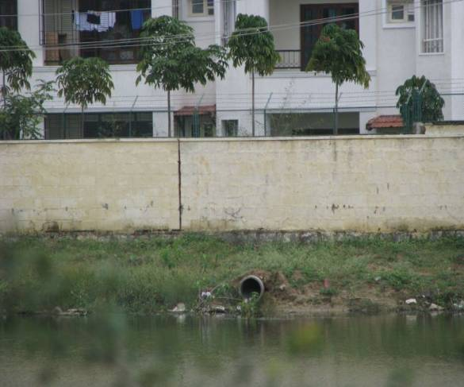

Picture 3c: Mud being dumped along the west bank

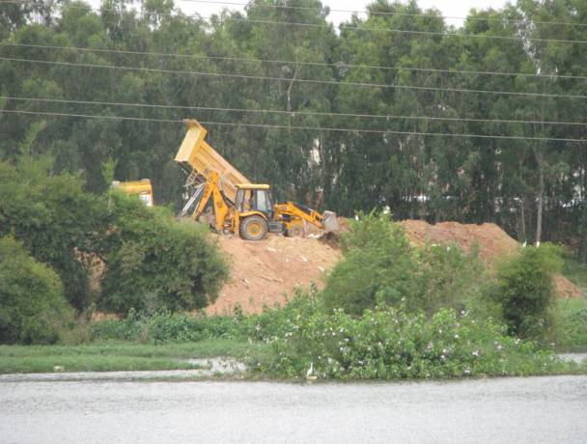

Picture 3b: Local people washing clothes along the south bank

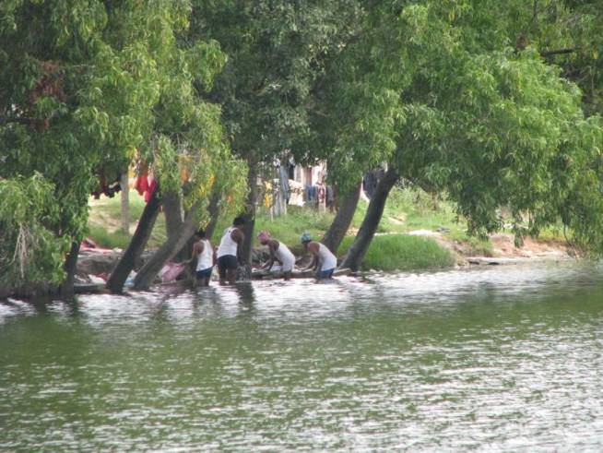

Picture 3d: Spot billed Pelicans observed at the lake

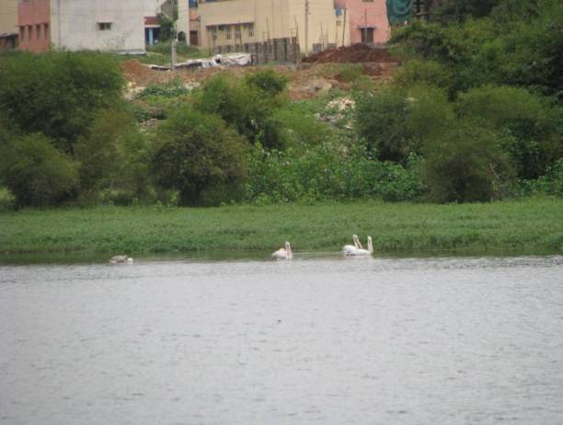

Picture 3e: Garbage dumped along the south east bank.

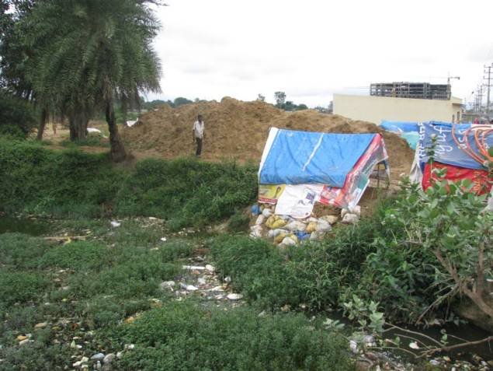

Picture 3f: Fishermen’s catch from Mahadevapura.

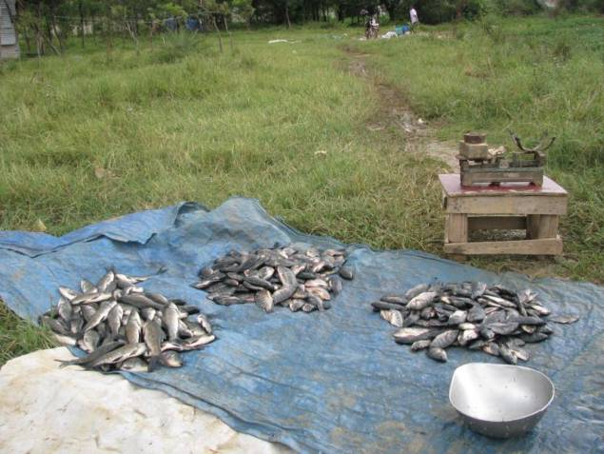

LAKES TO BE LEASED

Puttanahalli Lake , NH 209 (Kanakapura Road)

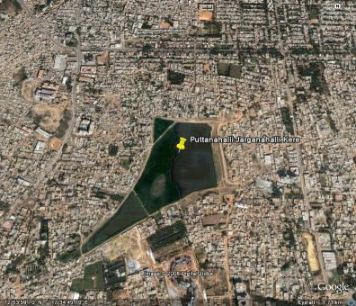
Google Earth Image of Puttanahalli Jagarahalli Lake

Date of survey: 19/10/2008
Form filled by: Krishnamurthy Nagarajan

This lake is situated south of JP Nagar 6th Phase ring road, at a distance of about 2 km. from Puttanahalli village. This lake falls within the limits of both Puttanahalli and Jaraganahalli villages. It extends to 5.67 hectares.

The water present is muddy and murky, but there is excessive growth of aquatic vegetation and the waters are eutrophicated. Both floating and anchored floating vegetation was observed.

The lake has been desilted & fenced by the LDA in 2005, and the west bank has been partially bunded. However, there is dumping of solid waste (including industrial waste) along the shore and part of the lake has been reclaimed for construction. On the Puttanahalli side, housing and industrial layouts have mushroomed, and sewage inflow poses a threat to the lake.

Picture 4a: View of extensive construction on the east bank (Puttanahalli side)

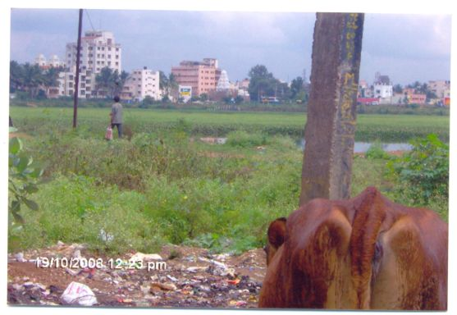
Picture 4b: Solid waste being dumped on the west bank (Jarganahalli); The lake is extensively eutrophicated.
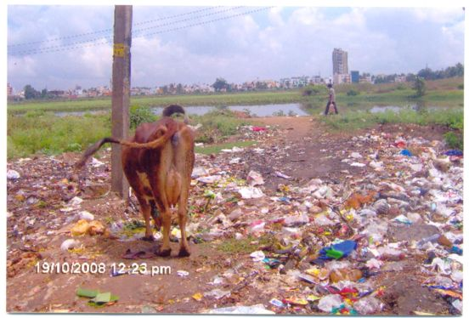

EXPRESSION OF INTEREST

LAKES TO BE LEASED

Arakere, Bannerghatta Road

Date of survey: 18th October 2008
Form filled by: Gitanjali Mahanti, Nandini Chami, Dolly Kalita, Environment Support Group

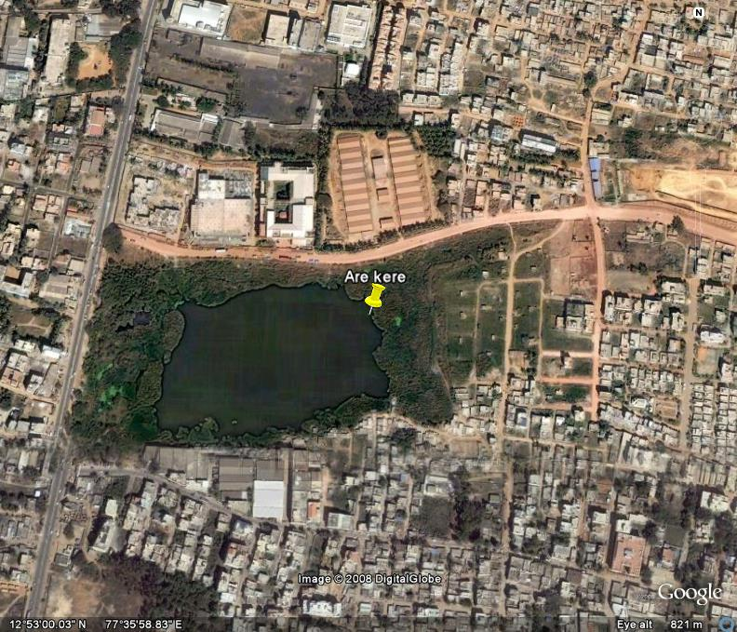
Google Earth Image of Arakere
Arakere Lake abuts Banerghatta Road, between Arakere and Hulimavu villages. It is a medium sized lake with an area of 15.16 hectares. This lake is proposed to be developed under the EOI scheme of the Lake Development Authority.
The very little water present is murky, almost blackish. The lake is severely eutrophied; most of the lake is covered with water hyacinth and other vegetation. The Bannerghatta road adjoins the West Bank of the lake, and there is also sewage inflow. The tank bund is on the eastern bank, and a BDA layout has been developed here. The north and south banks are separated from adjoining roads, by about 200 metres. The shores are overgrown with vegetation, and there is also dumping of waste.

Enquiries revealed that fishing, bathing and other uses have been abandoned because of excessive sewage inflow and the subsequent deterioration of the lake.

Picture 5a: Incinerated waste being dumped on the lake bank.

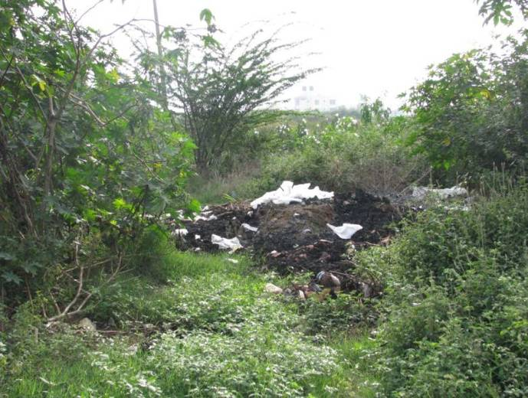

Picture 5c: Sewage discharge along the shore.

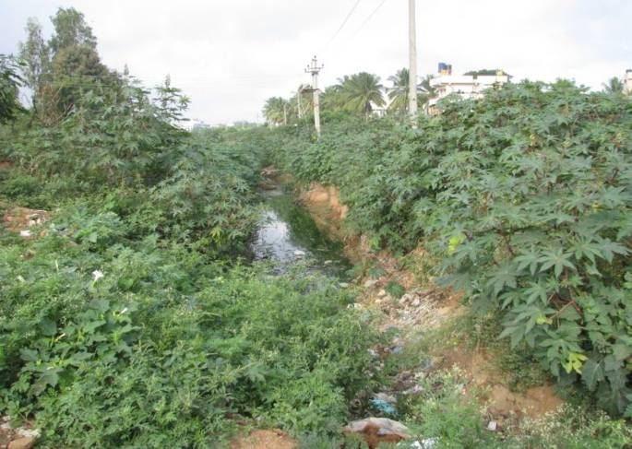

Picture 5b: Lake Water is murky. Fishing has been abandoned because of sewage inflow into the lake.

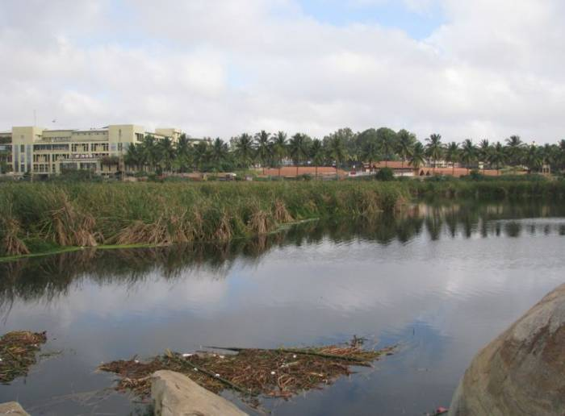

Begur Lake, Hosur Road

Date of survey: 18th October 2008
Form filled by: Gitanjali Mahanti, Nandini Chami, Dolly Kalita, Environment Support Group

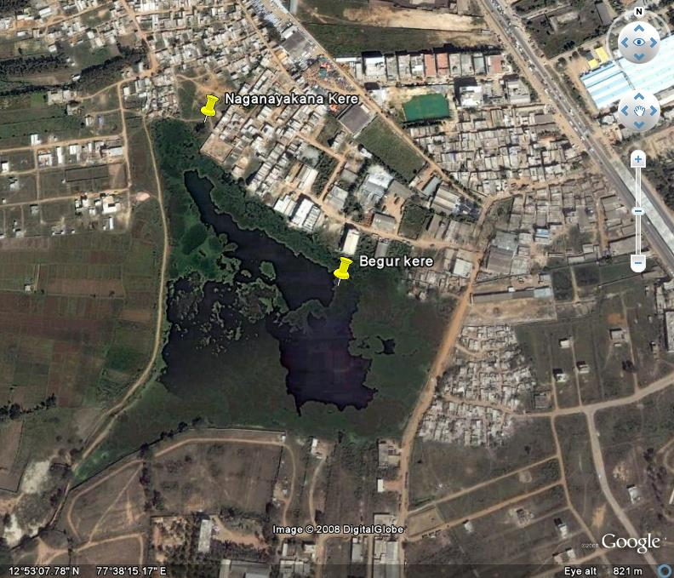
Google Earth Image of Begur Lake

The lake is located towards east of Begur and west of Hosur road. It is a medium size lake, extending up to 36.69 hectares in area. The lake is proposed to be developed under the EOI scheme of the LDA.

The water appears slightly clear. The survey team observed that the water is used for bathing, washing clothes and fishing. The road adjoins the west bank of the lake. The north and east banks are heavily built up. The survey team observed construction being carried on at the southwest end of the lake. Enquiries revealed that sewage flowed into the lake, along the north bank.

The tank used to irrigate paddy fields but the development of the region has put an end to all agricultural activities. One of the villagers was sharing with us the difficulty of finding suitable grazing grounds, considering the rampant growth of residential layouts.

Picture 6a: Construction activities being carried out at south west bank of the lake.

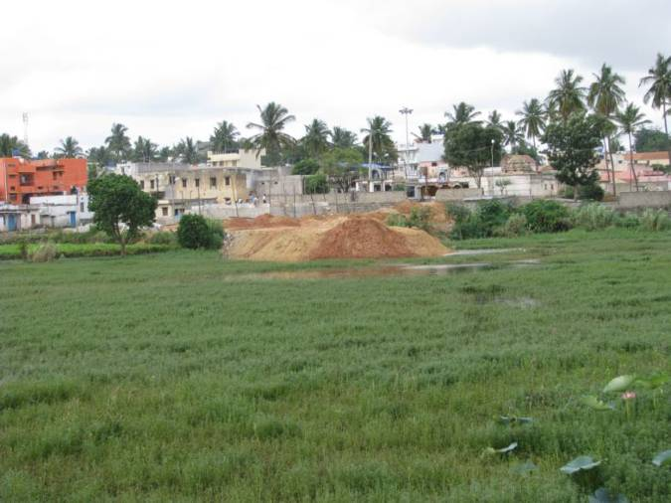

Picture 6b: Local people washing clothes at the lake

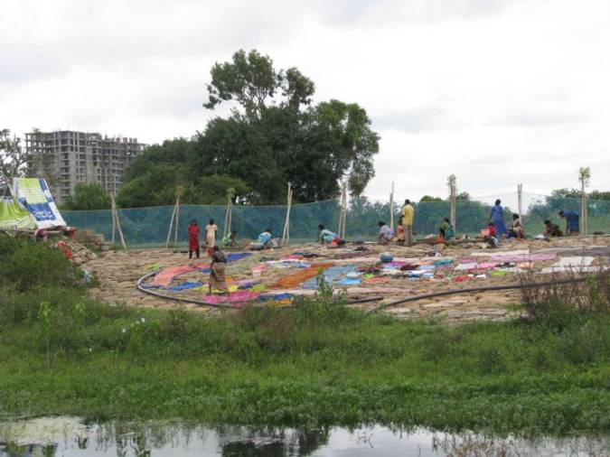

Bommasandra Lake, Hosur Road

Date of survey: 18th October 2008
Form filled by: Gitanjali Mahanti, Nandini Chami, Dolly Kalita, Environment Support Group

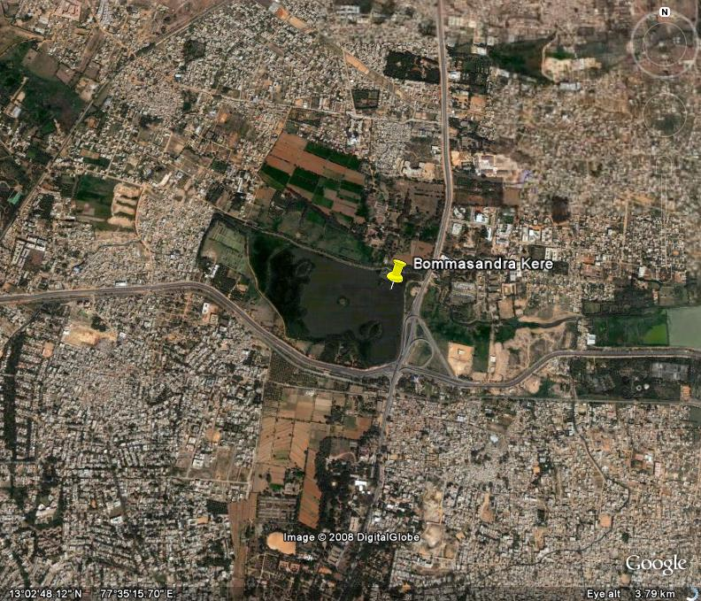
Google Earth Image of Bommasandra Lake
This lake is located near Bommsandra village, Hosur Road, Attibele Hobli. (Sy No.254 & 73). The lake measures 17.54 ha, and is proposed to be developed under the EOI scheme of the Lake Development Authority.
The water is slightly clear. Fishing is carried on in the lake, and a local resident has obtained fishing contract for this lake. Local people did not view sewage dumping as serious enough to affect fishing.

On the north bank of the lake, the survey team noticed that buildings have been constructed right up to the shoreline, and there was even a mud road leading right up to the lake. The east and west banks are also built up, but the south bank is relatively free from construction. However, the local people told us that even here; a BDA layout was being planned!

Picture 7a: Construction along the north bank of the lake upto the shoreline.

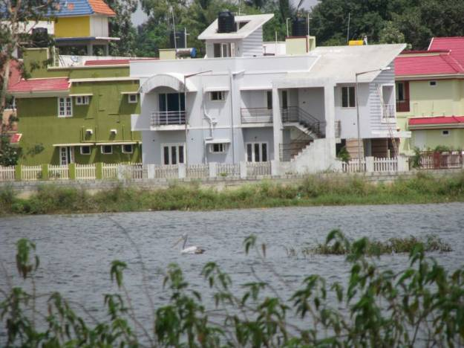

Picture 7c: Tent where fishing equipment is stored.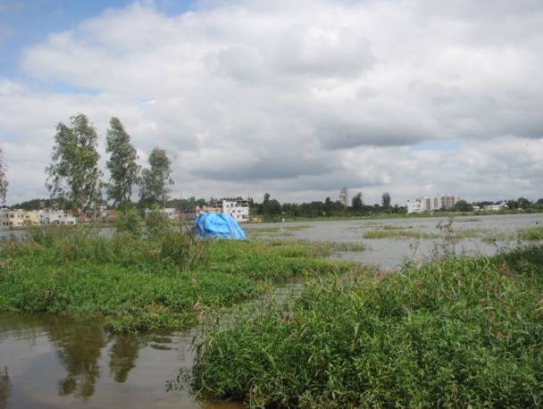

Picture 7b: Waste being dumped along the shore

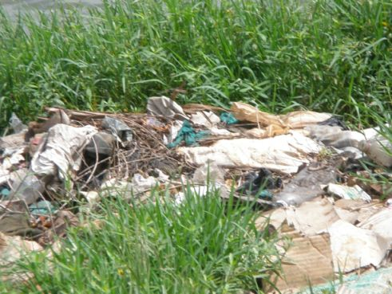

Doddanekundi Lake, K R Puram

Date of survey: 18/10/2008
Form filled by: Sharmila Bellur, Divya Ravindranath, and Sruthi Subbanna, Environment Support Group

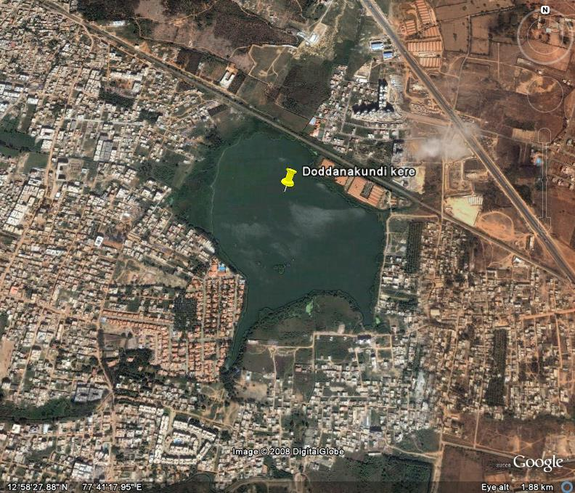
Google Earth Image of Doddanekundi Lake

The lake is located Doddanekundi village at K.R.Puram. It is a medium sized lake (47.08ha) and is blue in colour. This lake is proposed to be developed under the “Expression of Interest” scheme of the Lake Development Authority.

There is no fencing around the lake. There are weeds present at the north east bank of the lake and have been present since the past 10 years. Cows graze at this end of the lake. Local residents observe that the lake used to host a large number of waterfowl, especially “huge birds” in the past and that their numbers have reduced considerably over the years.

Houses are present on the north east end of the lake within approximately 50m. The layout that has been developed within the past 10 years since the real estate boom happened in Bangalore. Prior to that there were Paddy fields in the area. The houses do not come under BDA or any Panchayat and the untreated sewage from these houses is disposed into the north east corner of the lake.

Garbage is also being dumped at the bank close to the area where sewage is disposed, some of which also enters the water body and can be seen floating on the lake water. Some people also use the lake water for washing clothes. The residents of the area use bore well water for drinking purposes and have commented on a definite change in the taste of water over the years. The residents also commented on an increase in outbreaks of Chikun Gunya in the region.

There are huge buildings that are coming up at 250m from the north east bank of the lake. The labour working on construction of these buildings also lives at this end and the water used by them for bathing and other domestic purposes is also being discharged into the lake. All this has resulted in muddy grey water in the lake water around where the sewage, garbage, and other domestic waste are being discharged. It is just a matter of time before the whole lake becomes muddy grey water floating with garbage waste, making it aesthetically intolerant and subsequently slowly causing it to become eutrophic in nature.

Picture 8a: Construction of residential houses within 50m of Lake periphery on the Northeast end.

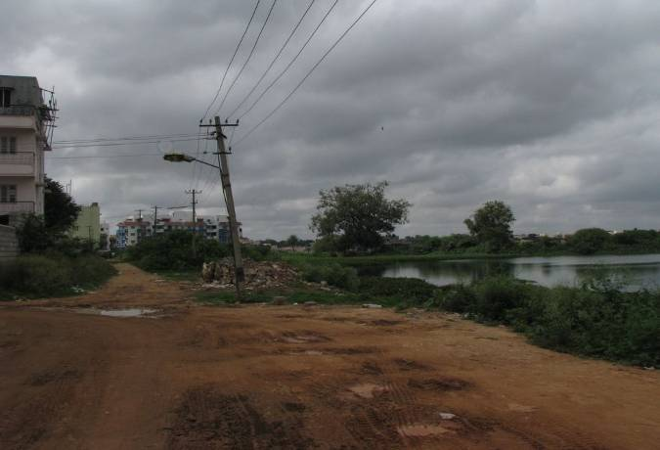

Picture 8c: Garbage dumped in the lake.

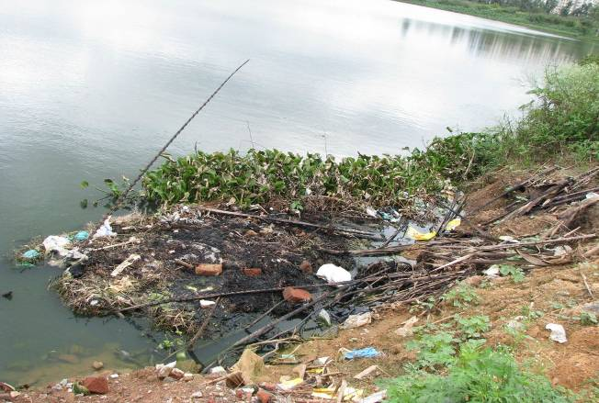
Picture 8b: Sewage being let into the lake

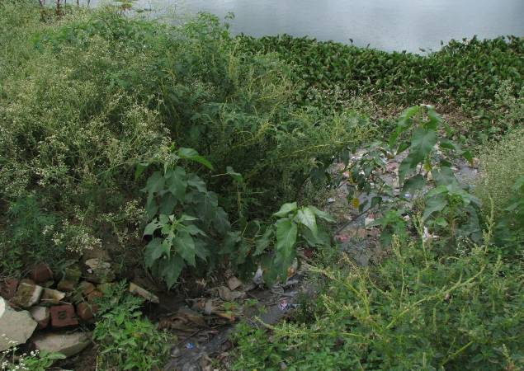

Picture 8d: Construction of huge building 250 m from lake periphery
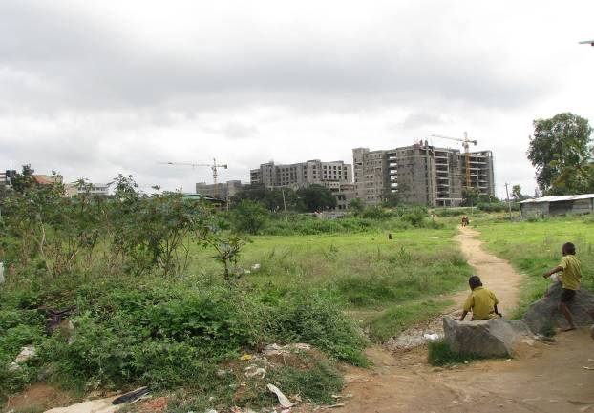

Hulimavu Lake, Near Hulimavu village, Bannerghatta Road

Date of survey: 18/10/2008
Form filled by: Gitanjali Mahanti, Nandini Chami, Dolly Kalita, Environment Support Group

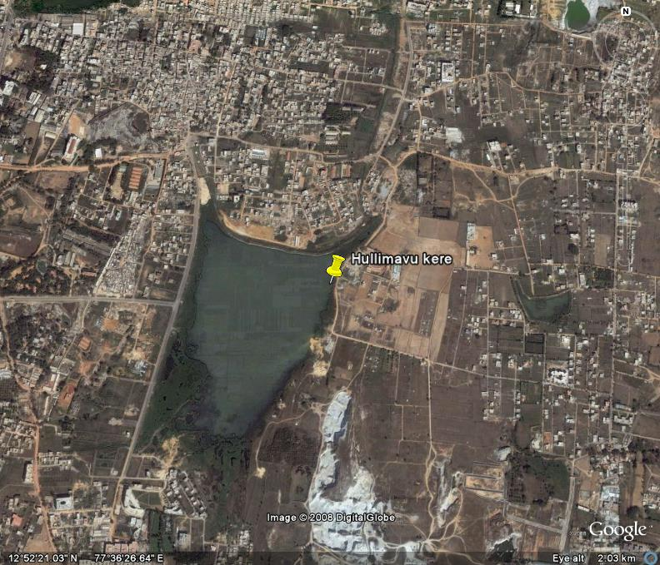
Google Earth Image of Hulimavu Lake

The Hulimavu Lake is situated near Hulimavu village, Bannerghatta Road (Survey No. 483). It is a medium size lake, extending to 50.30 ha. The Lake Development Authority has invited bids for this lake, under its Expression of Interest Scheme.

The Maruthi Dental College Road adjoins the West Bank of the lake, which also has a small shrine and a bore well. Some shoreline vegetation was observed along the west bank. Across the road, there is a brick kiln. Enquiries to the brick kiln owner, a long time resident of Hulimavu village revealed that there were fruit and vegetable gardens in the surroundings, which have now been replaced with residential layouts. The North and South banks of the lake are heavily built up, and on the east bank, there is a ‘gudda’ (hillock).

Though the water appeared somewhat clear, enquiries to local residents revealed that sewage is being dumped into the lake from the residential layouts. Because of sewage contamination, there is no fishing. The villagers from Hulimavu have stopped washing clothes, bathing or swimming in the lake as the water is contaminated. Mudlifting from the tank bed has become rampant, and this has altered the depth of the lake, according to local residents.

Picture 9a: Mud dumped along the west bank.

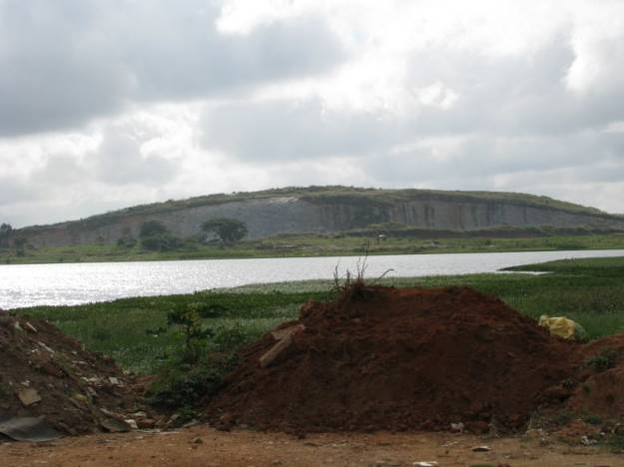

Picture 9b: Sand being segregated by jet stream processing with soil lifted from the lake bed.

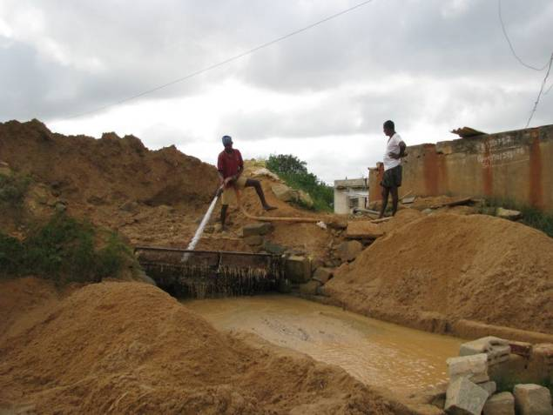

Naganaikana Lake, Begur village

Date of survey: 18 Oct 2008
Form filled by: Gitanjali Mahanti, Nandini Chami, Dolly Kalita, Environment Support Group

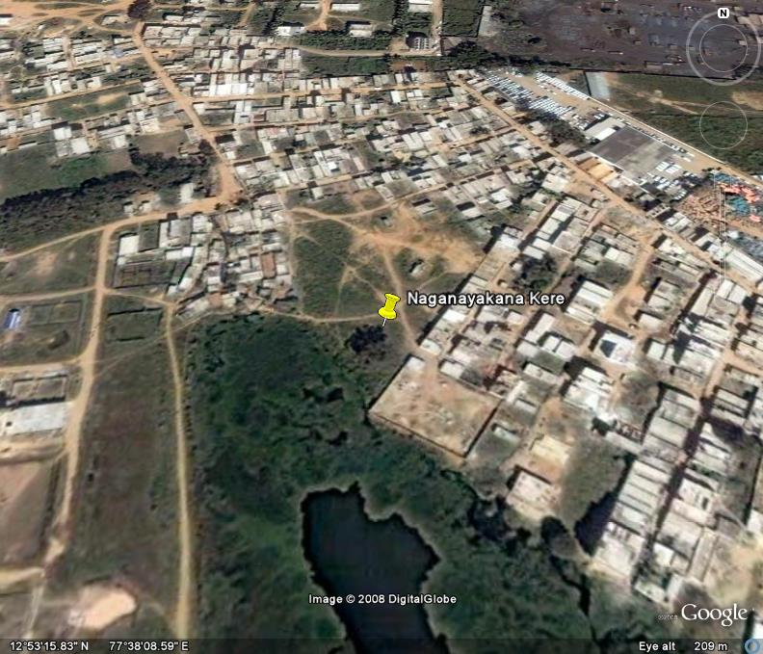
Google Earth Image of Naganaikana Lake

This lake is located near Begur village, Bommanahalli, Hosur Road. It is a medium sized lake, extending to 42.16 hectares, located in Sy. No. 168 of Begur & Sy. No. 86 of Singasandra. Locally, it is known as Singasandra Kere (not to be confused with the Singasandra Lake on Hosur Road). The lake that the residents used to refer to as Naganayakanahalli Kere, has been built over, according to them. Therefore, it may be assumed that only one of the two lakes are now present. Naganaikana lake has been proposed for development, under the Expression of Interest Scheme of the LDA.
Though water is present in the lake, it is murky and not used for drinking. When the survey team visited the lake, the water gave a foul stench. In spite of this, local residents use the water for washing clothes. This is because the village borewell has dried up, and residents have to purchase water for Rs1/ per pot for their daily use. This means they cannot spend too much water for washing clothes, and are forced to use the lake water for economic reasons. There is fishing, but local residents categorically told us that the fish is sold in Bangalore markets only and not locally.
The north bank of the lake is separated from the road by about 250 metres, but the residents told us that the land in between was being converted into BDA sites. The South and East banks are heavily built up, with buildings extending right up to the lake. Sewage contamination and encroachments pose a major threat to the lake.

Picture 10a: Buildings extending right upto the lake along the south bank.

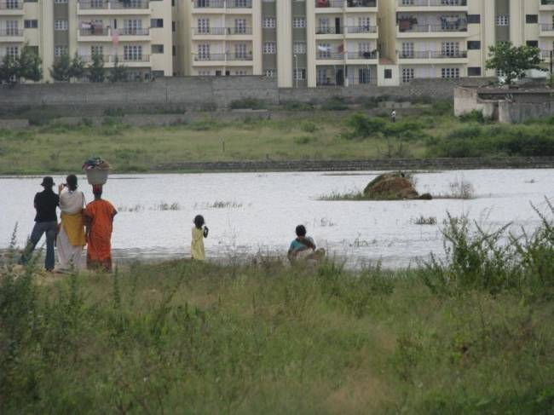

Picture 10b: Local villager washing clothes in the lake though water is foul smelling and solid waste is dumped along the bank.

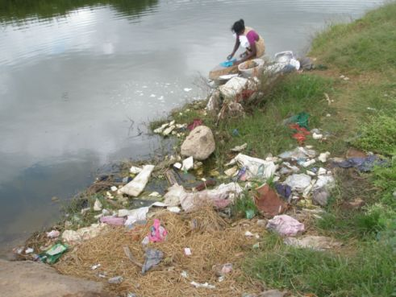

Varthur Lake, North-west of Varthur

Date of survey: 18/10/2008
Form filled by: Sharmila Bellur, Divya Ravindranath, and Sruthi Subbanna, Environment Support Group

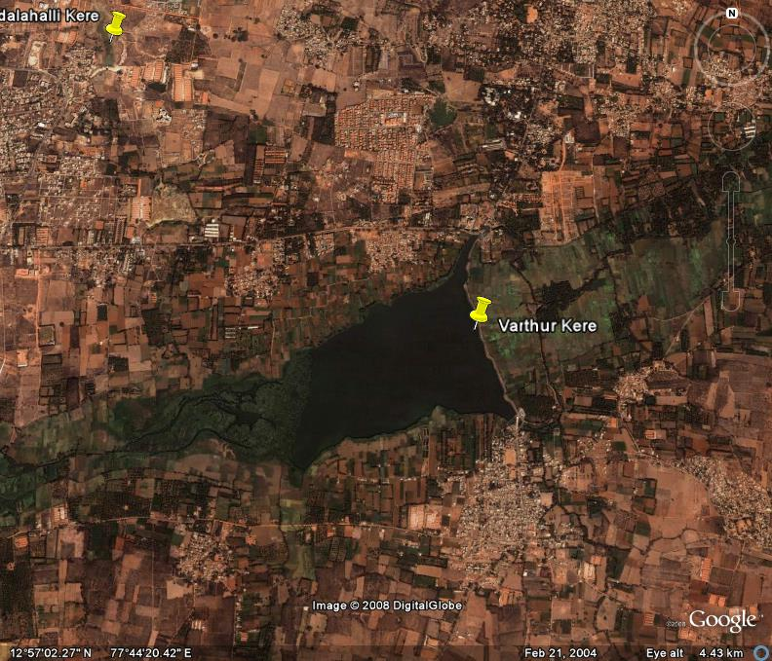
Google Earth Image of Varthur Lake

The lake is located south-east of Bangalore and north-west of Varthur. It is a huge lake (180.40 ha). This lake is proposed to be developed under the “Expression Of Interest” scheme of the Lake Development Authority.

The water is eutrophicated and foamy in nature with a distinct nauseating smell which seemed more as a result of discharge of industrial effluent rather than normal sewage. A road runs east of the lake wherein there is continuous movement of traffic. Bird life is sparse and aquatic vegetation abounds the lake, probably due to the high intake of untreated sewage. There are also some patches of algal blooms in certain pockets of the lake.

At the south end of the lake there is a bund via which water flows in a channel towards the farms; east of the road. These waters are frothy, are green in colour and emit a nauseating smell.

Huge farms, present east of the road, use either bore well or lake water for growing crops. The farmers of the area mentioned that the lake was very clean and clear before waste-water from the city started to get discharged into the lake. One of the farmers mentioned that they used bore well water previously to grow crops but over the past few years there has not been sufficient water coming out of the bore well and hence have started using lake water. He also mentioned that this was the last set of crops being grown on the land as the land has been sold to one of builders around the area.

Picture 11a: Water flowing from the lake is greenish.

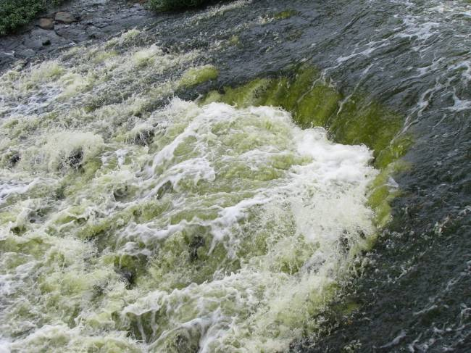

Picture 11c: Froth can be clearly observed where water falls from the lake bund

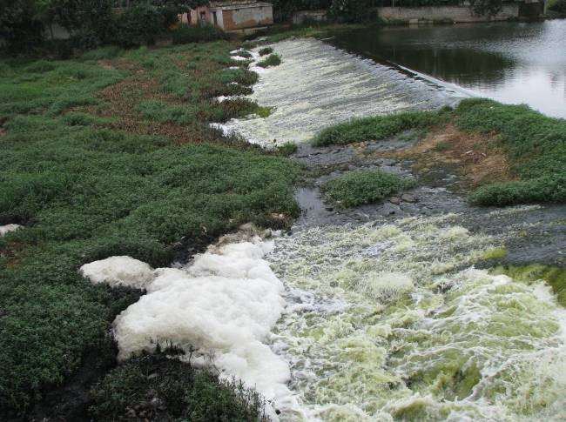

Picture 11b: Froth seen in backwater channels of Varthur lake

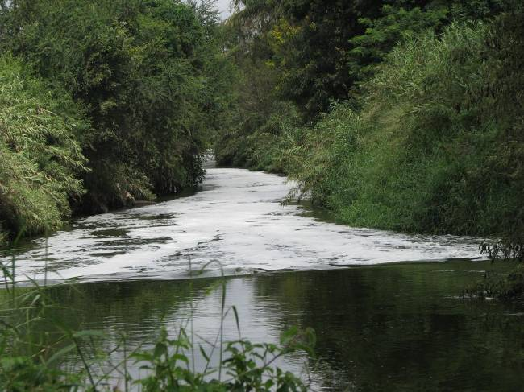

Picture 11d: Froth seen more clearly in the backwaters of Varthur Lake where there was a slight fall.

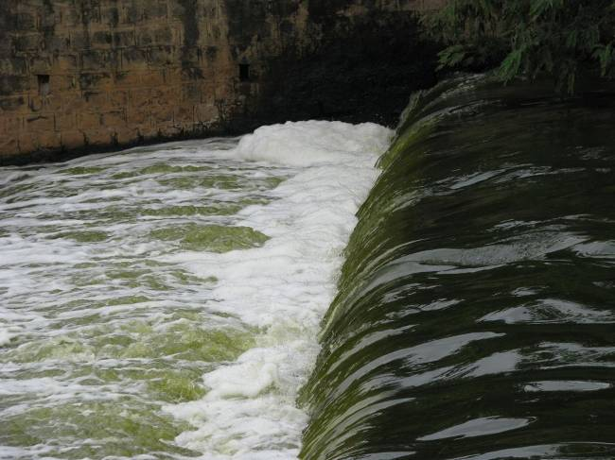

Picture 11e: Farms on opposite side of Varthur lake.

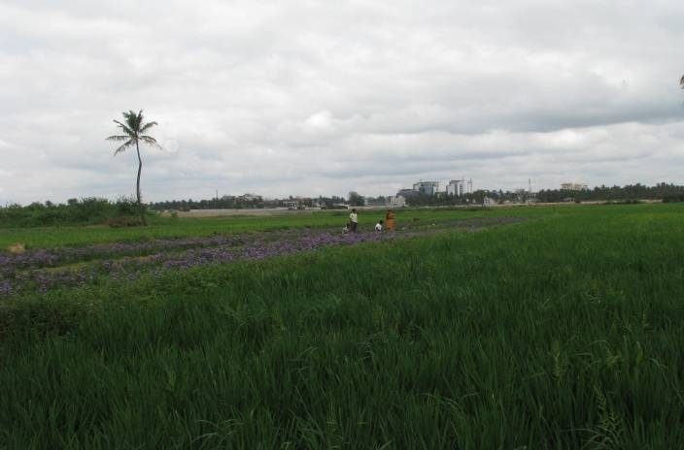
Yellammappa Chetty Lake, Northeast of K R Puram

Date of survey: 18/10/2008
Form filled by: Sharmila Bellur, Divya Ravindranath, and Sruthi Subbanna, Environment Support Group

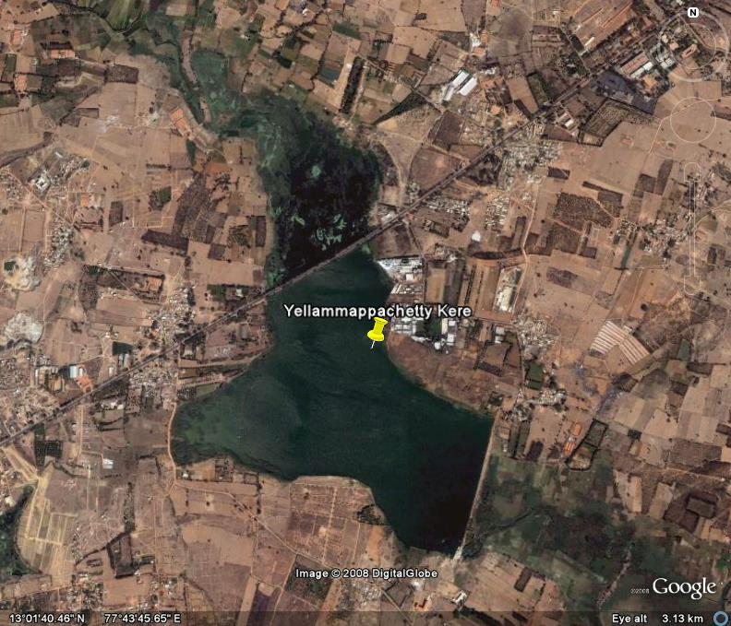
Google Earth Image of Yellammappachetty Lake

The lake is located north-east of Krishnarajapura and along Old Madras Road. It is a large lake (110 ha) with considerably clear water. This lake is proposed to be developed under the “Expression Of Interest” scheme of the Lake Development Authority.

Fishing is carried on, to a significant extent, and according to one of the fishermen in the area, the catch has reduced over the years. The fisherman also mentioned that sewage was being drained into the lake for the past 5 years, and he attributed the decrease in the number of fishes to this.

Garbage is being dumped along the western shore of the lake. In addition, there is a distinct smell of sewage coming from the lake.

Complaints have been made to government authorities about problems being faced by them due to the disposal of sewage, but no action has been taken till date. Cipla is one of the companies located at the east bank of the lake. This company used to discharge effluents into the lake, but this has been stopped after complaints were made against them by the fishermen of the area.

Picture 12a: Fishermen scaling the fishes

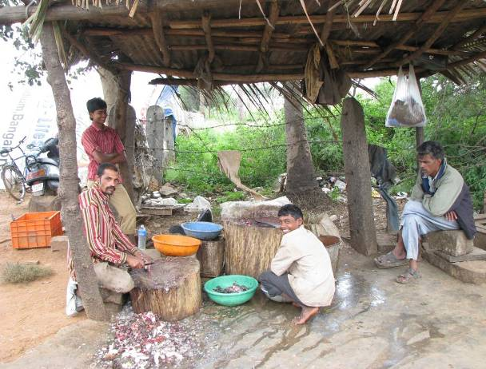

Picture 12c: The company, Cipla at the periphery of the lake.
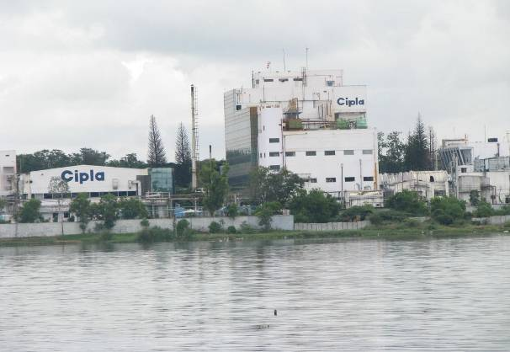

Picture 12b: Fishermen cleaning up their nets

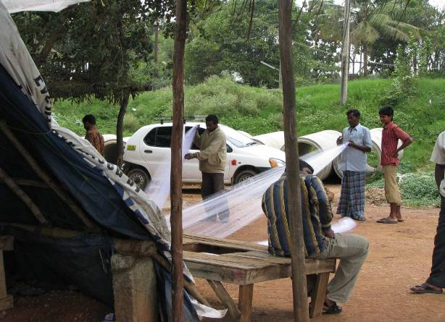

4.3.7284.3916 (beta) version
Information obtained from lease agreement dated 19th February, 2007, between Lake Development Authority and Sri Rajarajeshwari Devasthana Trust. The lease agreement was accessed through the Right to Information Act.
Information obtained from Statement of Objections filed on behalf of LDA, in W.P No. 817/2008 dated 3rd June 2008.
Details of survey number are as per lease agreement dated 19th February, 2007, between Lake Development Authority and Sri Rajarajeshwari Devasthana Trust.
4.3.7284.3916 (beta) version
Information obtained from lease agreement dated 4th February, 2006, between Lake Development Authority and M/s Kalyani Developers. The lease agreement was accessed through the Right to Information Act.
Information obtained from Statement of Objections filed on behalf of LDA, in W.P No. 817/2008 dated 3rd June 2008.
Details of survey number are as per lease agreement dated 4th February, 2006, between Lake Development Authority and M/s Kalyani Developers.
4.3.7284.3916 (beta) version
Information obtained from lease agreement dated 16th February, 2006, between Lake Development Authority and M/s Abhishek Developers. The lease agreement was accessed through the Right to Information Act.
Information obtained from Statement of Objections filed on behalf of LDA, in W.P No. 817/2008 dated 3rd June 2008.
Details of survey number are as per lease agreement dated 16th February, 2006, between Lake Development Authority and M/s Abhishek Developers.
4.3.7284.3916 (beta) version
Retrieved from http://ldakarnataka.co.in/AaL_2007.html; last accessed on 18th November, 2008
4.3.7284.3916 (beta) version
Retrieved from http://ldakarnataka.co.in/EOI-5.htm; last accessed 18th November, 2008.
Retrieved from http://ldakarnataka.co.in/EOI-5.htm; last accessed 18th November, 2008.
4.3.7284.3916 (beta) version
Retrieved from http://ldakarnataka.co.in/EOI-5.htm; last accessed 18th November, 2008.
Retrieved from http://ldakarnataka.co.in/EOI-5.htm; last accessed 18th November, 2008.
4.3.7284.3916 (beta) version
Retrieved from http://ldakarnataka.co.in/EOI-5.htm; last accessed 18th November, 2008.
4.3.7284.3916 (beta) version
Retrieved from http://ldakarnataka.co.in/EOI-5.htm; last accessed 18th November, 2008.
Retrieved from http://ldakarnataka.co.in/EOI-5.htm; last accessed 18th November, 2008.
4.3.7284.3916 (beta) version
Retrieved from http://ldakarnataka.co.in/EOI-5.htm; last accessed 18th November, 2008.
Retrieved from http://ldakarnataka.co.in/EOI-5.htm; last accessed 18th November, 2008.
4.3.7284.3916 (beta) version
Retrieved from http://ldakarnataka.co.in/EOI-5.htm; last accessed 18th November, 2008.
Retrieved from http://ldakarnataka.co.in/EOI-5.htm; last accessed 18th November, 2008.
4.3.7284.3916 (beta) version
Retrieved from http://ldakarnataka.co.in/EOI-5.htm; last accessed 18th November, 2008.
Retrieved from http://ldakarnataka.co.in/EOI-5.htm; last accessed 18th November, 2008.
4.3.7284.3916 (beta) version
Retrieved from http://ldakarnataka.co.in/EOI-5.htm; last accessed 18th November, 2008.
Retrieved from http://ldakarnataka.co.in/EOI-5.htm; last accessed 18th November, 2008.

